**BITS-PILANI – DUBAI, Dubai International Academic City, Dubai, UAE**

**Course Title : Computer Networks**

**Tutorial-9**

1. The figure below shows an IP datagram fragmentation example . A datagram of 4,000 bytes (20 bytes of IP header plus 3,980 bytes of IP payload) arrives at a router and must be forwarded to a link with an MTU of 1,500 bytes. Suppose that the original datagram is stamped with an identification number of 777. Show the characteristics of three fragments

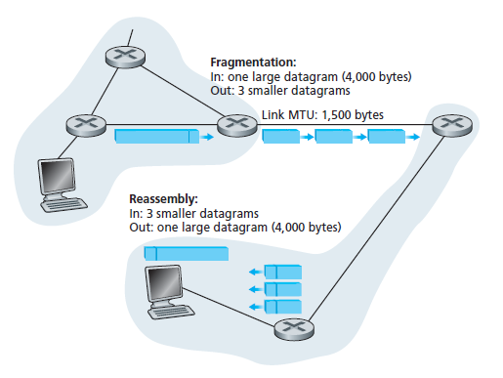

1. Consider an IP message 12000 bytes wide (including the 20-byte IP header) that needs to be sent over a first link with an MTU of 3300 bytes. And 2 second link with MTU of 1300 bytes. Show the characteristics of all the fragments in both the link.